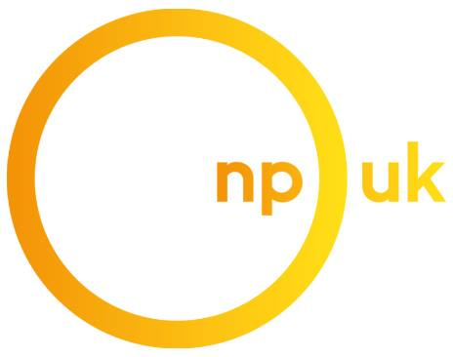 | COVID-19  Response Fund | 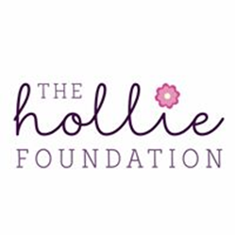

In response to the COVID-19 crisis and in recognition that many in our community are being impacted by lockdown, NPUK Trustees have designated £10,000 to create a new grant scheme for patients and families. The Hollie Foundation, in acknowledgement of our shared goals, has generously contributed a further £2,500, increasing our ability to provide much-needed-support.

The aim of this limited fund is to assist those experiencing hardship or unexpected expense as a direct result of the Coronavirus pandemic, which threatens to impact their physical or mental well-being.

You might want to apply if:

- You or a family member (s) are affected by Niemann-Pick disease
- You are shielding or self-isolating and are not entitled / able to access sick pay
- You have been made redundant as a result of the pandemic
- You have been furloughed (temporarily laid-off)
- Your working hours have been reduced
- You have been asked to take unpaid leave
- You have lost self-employed income and are not eligible to apply for the new Self Employed Income Support Scheme (SEISS)
- You or a family member are struggling with your mental or physical health
- You have unexpected expenditure due to the crisis, i.e. higher food bills, activities for children
- You are experiencing hardship in other ways (please explain in your application form)

Grants will be awarded on a needs basis and at the discretion of our team, receipts will be required in all cases. Vouchers may be awarded in some cases.

Please complete the following form to apply. If you need assistance, please contact any member of our team:

Elizabeth Davenport, Senior Families Advocate, Tel: 07896 197 576 Email: elizabeth@npuk.org

Karen Thomas, Families Officer, Tel: 07423 106 595 Email: karen@npuk.org

Steve Neal, Families Officer, Tel: 07787 818 885 Email: steve@npuk.org

Laura Bell, Clinical Nurse Specialist, Tel: 07791 499 555 Email: laura@npuk.org

Louise Metcalfe, Project Coordinator, Tel: 07423 112 139 Email: louise@npuk.org

Application Form

Grants of up to £200 will be made to patients and families affected by Niemann-Pick disease (NP-C or ASMD NPA or NPB), who require support in the following categories:

- Financial Hardship or unexpected expenditure
(Including but not limited to, food / grocery / household bills)

- To assist and encourage emotional or physical well-being
(Items or equipment for activities that may help to build resilience, increase confidence, reduce anxiety and help to ease isolation, including but not limited to, exercise equipment, games / craft & educational supplies / electronic equipment / garden play items)

Applications of up to £200 can be made in one or both categories.

Section 1: About You

Your Name:

Your Email Address:

Your Telephone Number:

Your Home Address:

Are you making this application on behalf of an affected individual? Yes / No

If yes, what is your relationship to the affected individual?
- Parent
- Carer

If you are applying in a different capacity, please tell us here.

In order for us to be able to process any special category data disclosed within this application (for example health, medical, genetic details) we require your explicit consent.

If applying on behalf of someone, you must have the legal capacity to give consent on behalf of the person you are applying for.

I give Niemann-Pick UK explicit consent to process any special category data disclosed within this application form for the purpose of administration, consideration, recording and processing of this grant application:

Yes / No

Section 2: Your Application

I / we would like to apply for funding to support:

- Financial Hardship or unexpected expenditure
(Including but not limited to, food / grocery / household bills)
- To assist and encourage emotional or physical well-being
(Items or equipment for activities that may help to build resilience, increase confidence, reduce anxiety and help to ease isolation, including but not limited to, exercise equipment, games / craft & educational supplies / electronic equipment / garden play items)
3. Both of the above - you can apply for up to £200 per category

Please tell us briefly the reason for your application
(we might contact you for more information)

Please tell us how you will use the grant funding, if awarded:

Please tell us what difference this funding would make:

What is the total amount you are asking for?
Category 1. £
Category 2. £

SECTION 3: Your Data and Contact preferences

Data Protection Statement
The protection of personal privacy is an important concern to Niemann-Pick UK. Any personal data collected will be treated in accordance with current data protection legislation.

We will use your personal data to evaluate and process your grant application and to administer any grant awarded. In order to evaluate your application your personal data provided within this application will be shared with the NPUK Staff Team. For more information about our data protection policy please go to www.npuk.com

The information collected on this form will be stored securely and only be used to provide the service(s) that you have requested and communicate with you in the way(s) you have agreed to.

Your details may also be used for analysis purposes, to help us provide the best possible service. We will not share your details with any third party unless required to do so by law.

We would like to keep you up to date with NPUK news, events and activities, but only with your permission! If you’re happy with this, please tell us how you would like to be contacted by ticking all the relevant boxes below:

-  Post
-  Phone
-  Email
-  SMS (Text), Messenger, WhatsApp

To change these options at any time call us on 0191 4150693 or email info@npuk.org
You can also write to us at:

NPUK
Suite 2 Vermont House
Concord, Washington
Tyne and Wear
NE37 2 SQ

SECTION 4:
Signature (to be completed by applicant or Parent/carer of affected individual)

I confirm that I am at least 18 years of age: Yes / No

Your Name:

Signature: Date:

Please return this form by email to any member of our team or to info@npuk.org

SECTION 4: NPUK Use Only

For Office Purposes Only:
Grant Recommended by: | Grant Approved by: | Date Approved:
Receipts received: | Grant type:  Direct payment / utility payment / voucher / NPUK purchase

