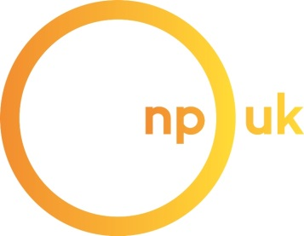

Niemann-Pick UK – Gift Aid Declaration

Make your gift go further, at no cost to you.

As long as you are a UK taxpayer, NPUK can reclaim 25p per £1 in tax on your donations. All you need to do is complete this form and tick the ‘yes’ box below.

You can still help us even if you don’t pay tax - by ticking the “no” box, you’ll help us keep our records up to date, and we will know not to ask you again about Gift Aid.

Title: ______ First Name: ___________________ Surname: ___________________

Address: _________________________________________________________

__________________________________________________________

______________________________ Post Code: __________________

Telephone: ______________________________

Email: __________________________________

YES- please claim Gift Aid on all donations I have made in the last six calendar years, and until further notice.

Please notify us if you no longer pay an amount of UK Income Tax and/or Capital Gains Tax at least equal to the tax that we will reclaim on your donations in the appropriate tax year (6 April one year to 5 April the next). Thank you.
NO- sorry, I can’t Gift Aid.

Signed

Date

